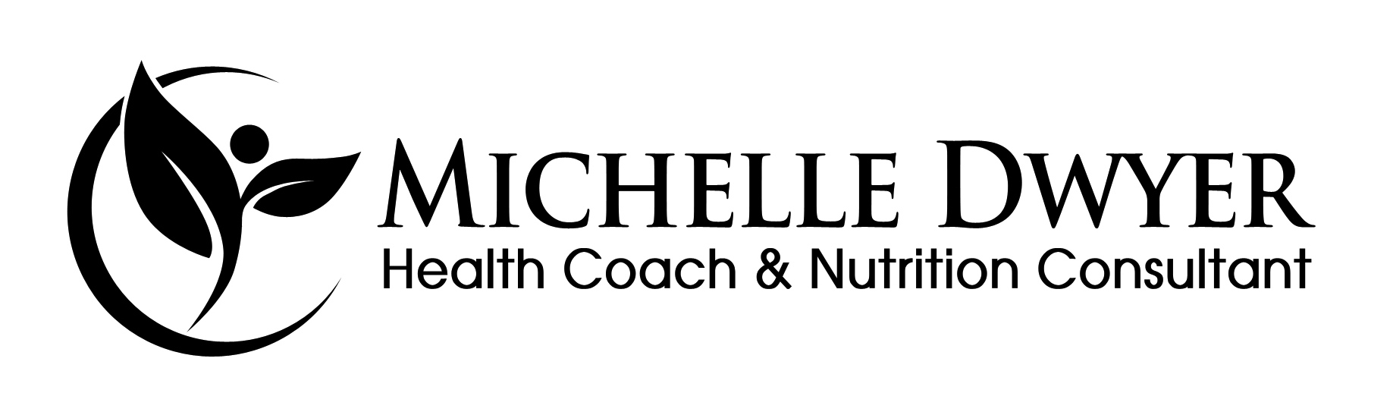
Client Disclosure

To: _____________________________________

I am a holistic health coach and nutrition consultant. I am not a licensed physician, nor are my services licensed by the state of California. The idea behind holistic health and nutrition is that I support my clients by addressing the needs of the body, mind and spirit. My services include suggestions for food, nutritional supplements, stress management techniques, mindfulness strategies, and exercise programs.

I have a Master of Science degree from Hawthorn University in Health Education and Nutrition. I am a member of the National Association of Nutrition Professionals (NANP) and a candidate for the NANP Board Certification in Holistic Nutrition®. I am also a member of The American Association of Nutritional Consultants (AANC). I also hold a California Teaching Credential.

I am not a doctor and do not diagnose or treat disease, nor make recommendations regarding medical treatment or medications. My method of treatment, holistic health coaching and nutrition consulting, is alternative or complementary to healing arts that are licensed by the State of California. Under Sections 2053.5 and 2053.6 of California’s Business and Professions Code, I can offer you these services, subject to requirements and restrictions.

If you ever have any concerns about the nature of your treatment, please feel free to discuss them with me. I recommend that you inform your medical doctor that you are receiving treatment in holistic health and nutrition.

In order to use my services, California state law requires that you acknowledge receipt of the information provided in this form and that you sign it. You will receive a copy. I will keep the original in my records for at least three years.

Acknowledgement and Consent to Receive Services:

I have read and understand the above disclosure about the treatment offered by Michelle Dwyer and Michelle Dwyer’s training and education. I have discussed with Michelle Dwyer the nature of the services to be provided. I understand that Michelle Dwyer is not a licensed physician and that holistic health coaching and nutrition consulting services are not licensed by the state of California. I understand it is my responsibility to maintain a relationship for myself/my child with a medical doctor. I have consented to use the services offered by Michelle Dwyer, and agree to be personally responsible for the fees of Michelle Dwyer in connection with the services provided to me.

Name of client: ____________________________

Signed: ___________________________________ Date: ________________
(client/parent/conservator/guardian)

Indicate relationship to client, if other than client _____________________

